Big Mountain Resort is experiencing an increase of $1.54MM in operating costs this season after the addition of a new ski lift. The current lift ticket pricing strategy involves charging a premium on the average price of market competitors. Pricing and investment strategy can be improved with increased knowledge of competitor’s pricing as it relates to the competitive resort’s attributes. After completing my analysis, I am recommending a lift ticket pricing increase of $4 to $85 based on competitive pricing and supported by a random forest regression model. Additionally, future investments in the ski area should focus on adding a run, increasing the vertical drop by 150 feet, and installing an additional chair lift.

I started the analysis with a high-level overview of the ski resorts data by viewing rankings in state level summary statistics such as population, size, and skiable terrain. Other features were appropriate for conversion into density ratios such as resorts per 100k in population and square mileage. These steps were the beginning of my attempt to gain an understanding of the relationship between state and ticket price. Given the need to understand how 7 numerical state features are related, I performed a principal component analysis and determined that we can essentially treat all states equally. Big Mountain’s position in the Montana ski market was considered in the end.

A random forest regression was modeled and determined top features relating to lift ticket pricing.

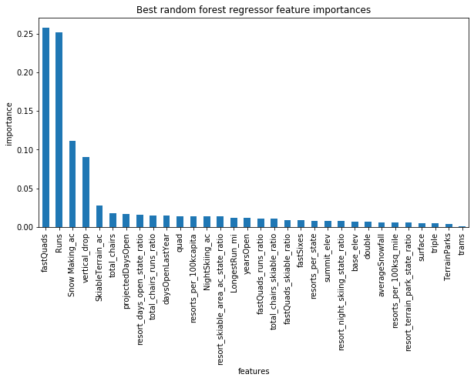

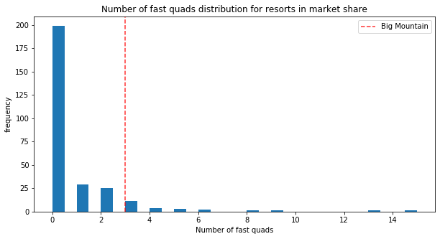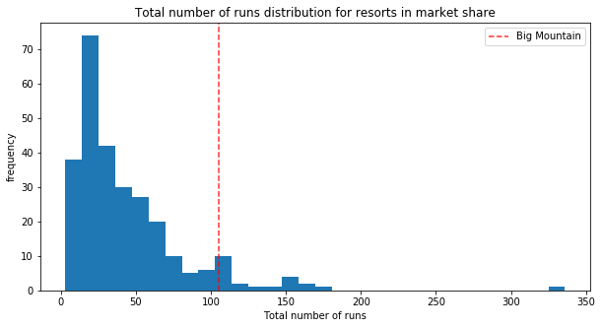Big Mountain is positioned well in many of the top features and is in extraordinarily strong position for the top two contributors to price, fast quads and total number of runs.

Big Mountain currently charges $81 for an adult weekend lift ticket and does not vary price based on day of week. Big Mountain's current pricing strategy could be lower than modeled due to the local state market for ski resorts. Our models treated all resorts equally, as supported by some EDA on state data, but we see that Big Mountain is already the most expensive resort in the state of Montana. It's also a difficult and costly place to get to if you're not a local. Given these considerations, the recommended price increase of $4 is $9 below the modeled price of $94. There was also an absolute mean error of $10 providing further support for a conservative pricing increase.

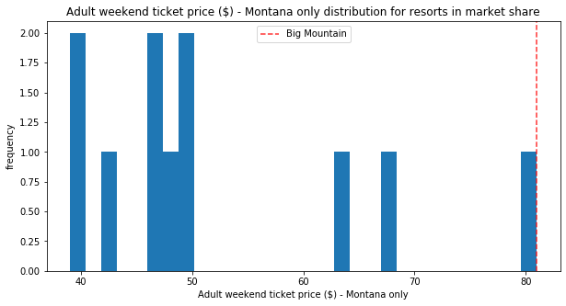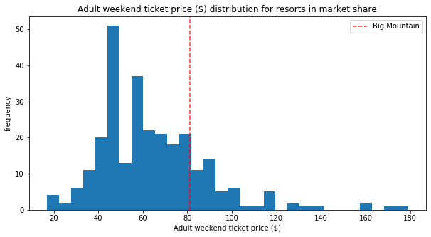

The most important information missing from our models is the number of skiers buying tickets each day. While a $4 ticket increase translates to $7MM in annual revenue, this number assumes continued sales volume of 350,000 annual skiers buying an average of 5 lift tickets. A moderate decline in ticket sales would still allow for a revenue positive price increase and will cover the increased operating cost of $1.54MM for this season. Future investments in the ski area with focus on adding a run, increasing the vertical drop, or installing an additional chair lift may allow for additional price increases if this one proves successful.